**21k-3881**

**LAB 09 (CN)**

**Task 01:**

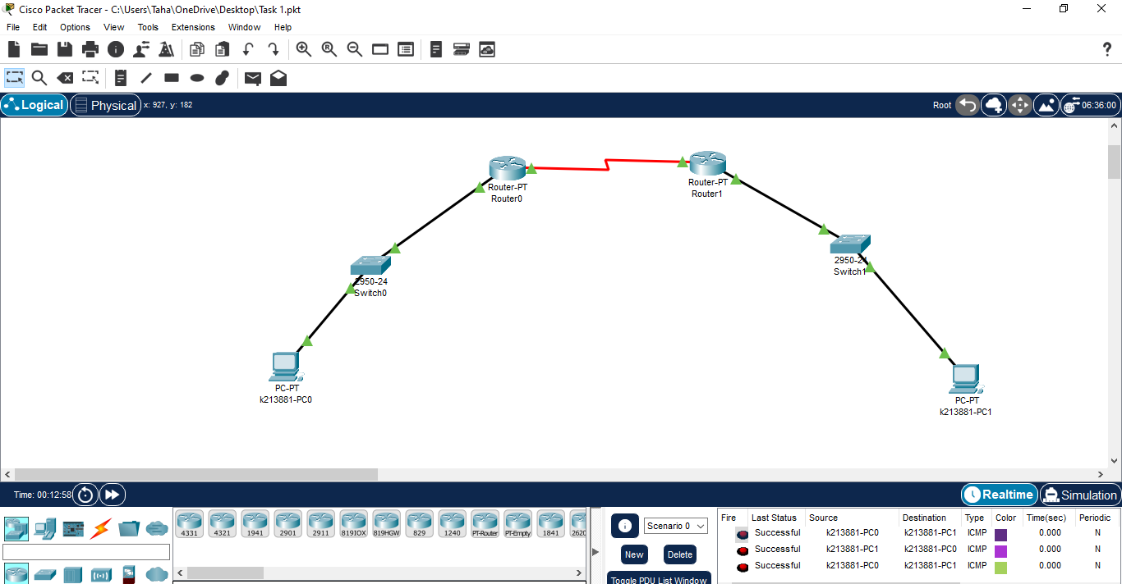

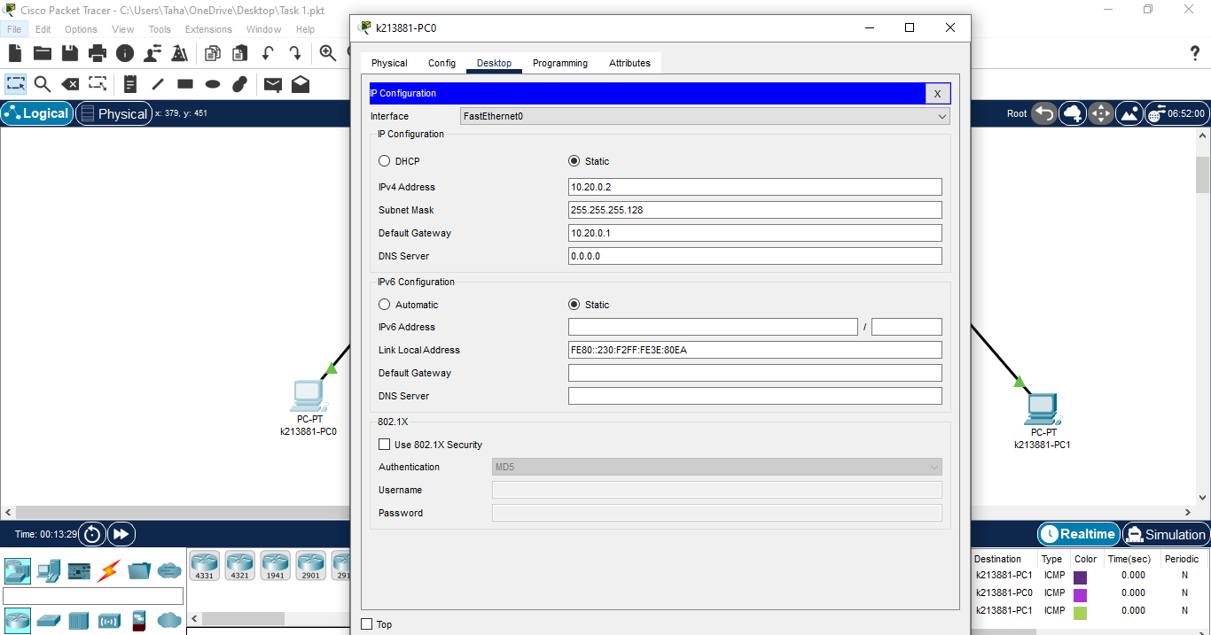

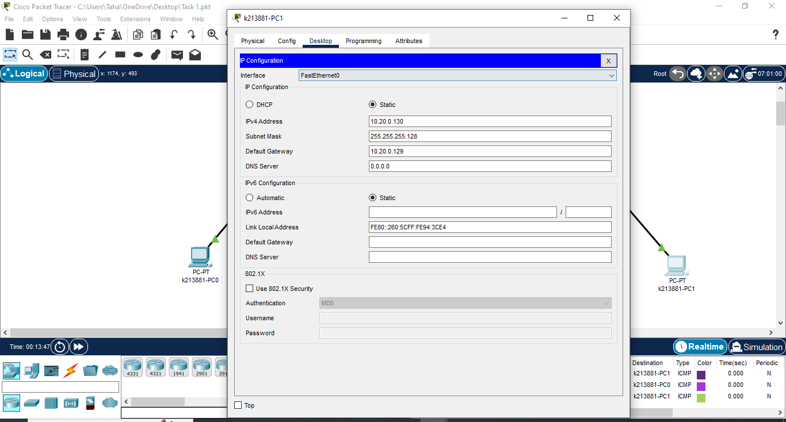

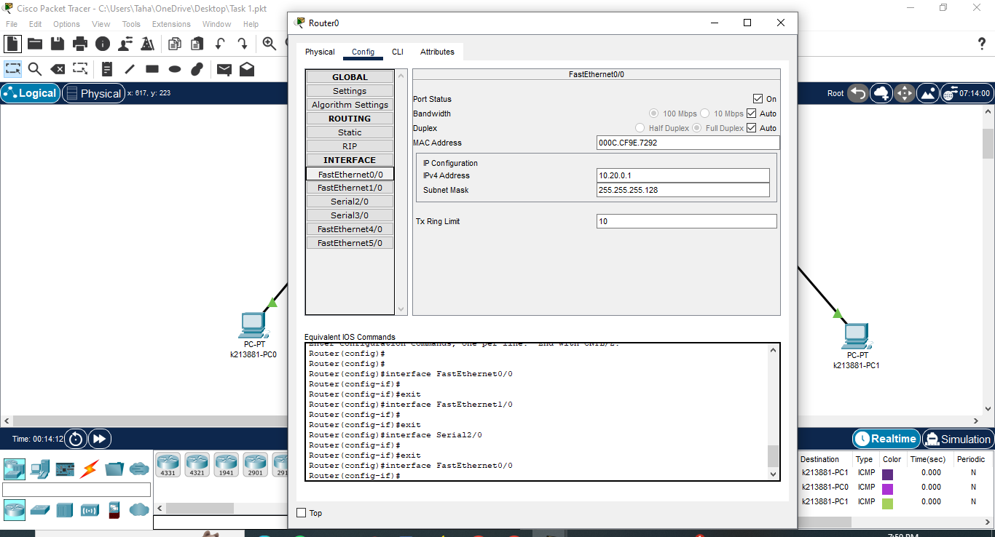

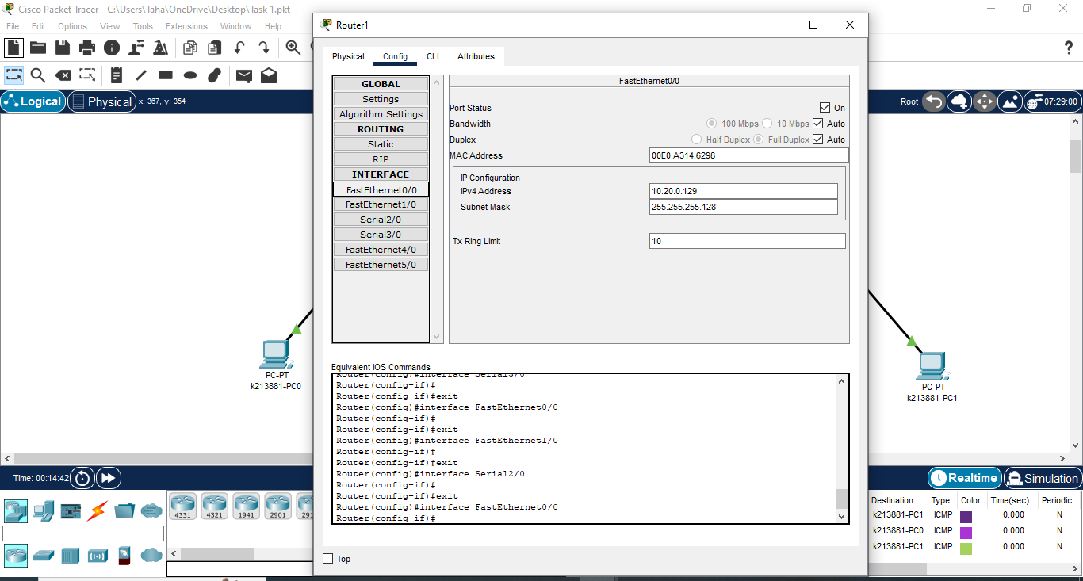

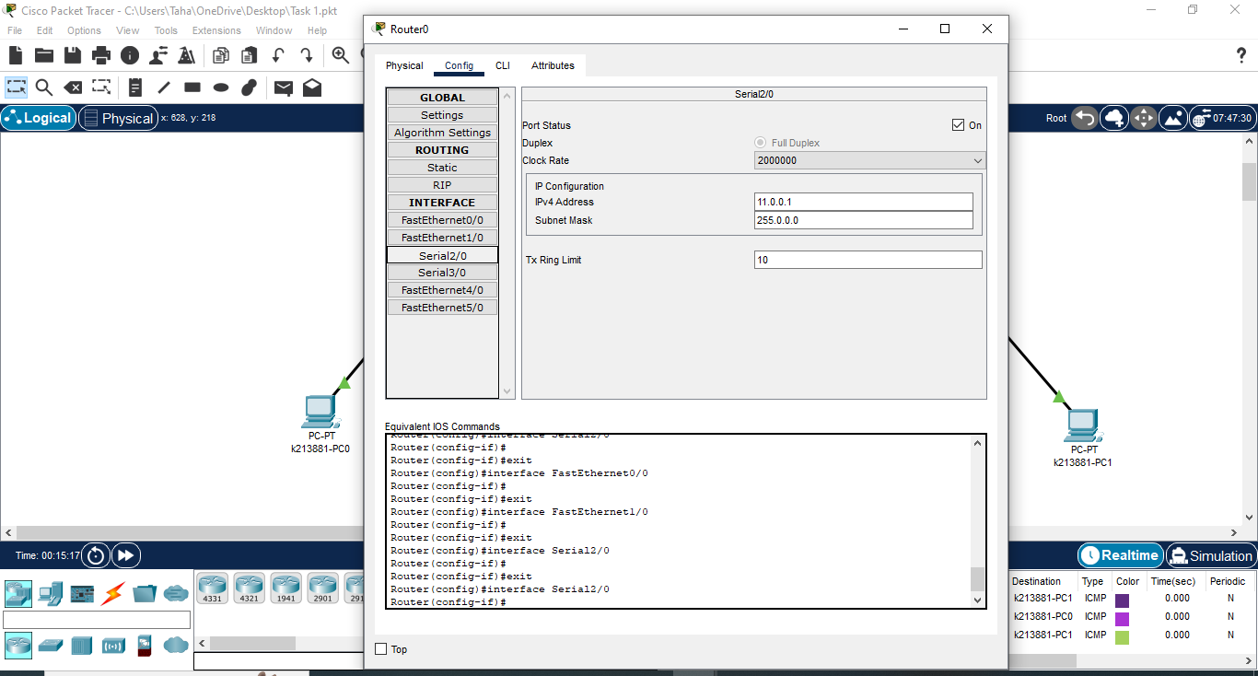

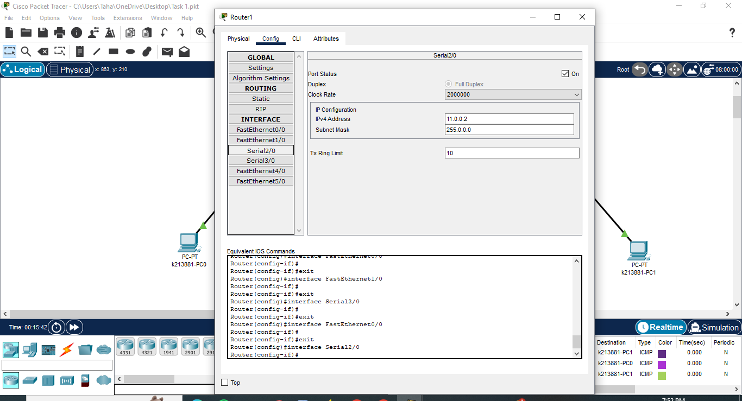

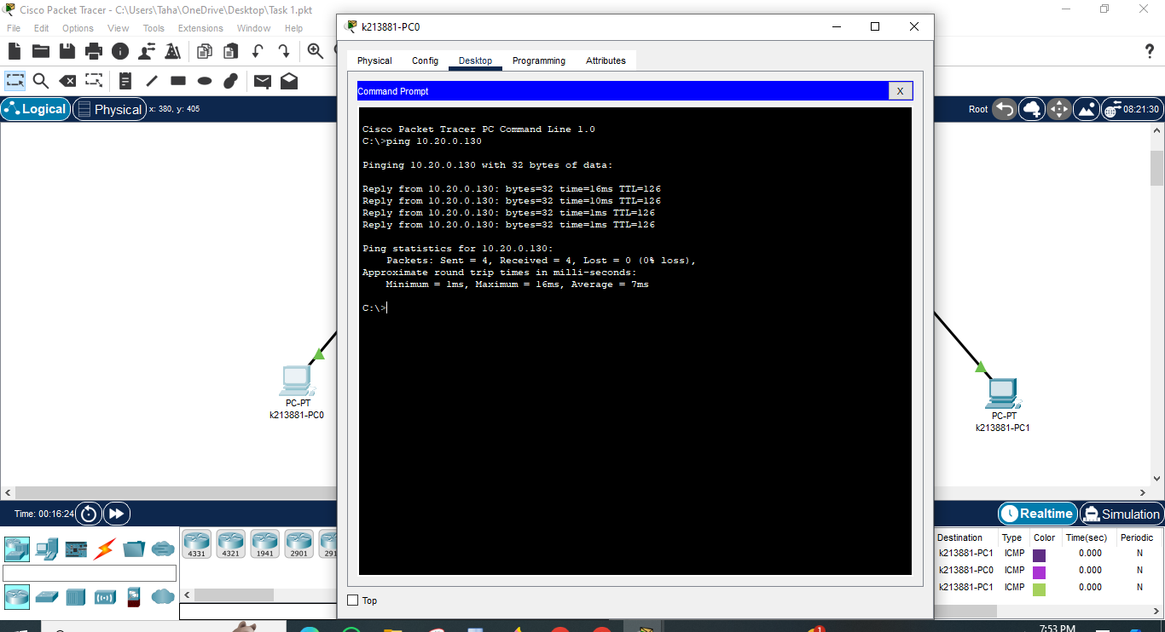

**Task 02:**

**DEVELOPMENT=120Hosts FINANCE = 35Hosts**

## HR = 10Hosts

## For DEVELOPMENT = 120 HOSTS

27=128

Total Bits of IP Address = 32 32 – 7 = 25

Thus, the subnet mask has 25 bits represented as: 200.16.100.0/25

IP = 200.16.100.0

So in subnet mask first 25 bits will be 1’s and remaining 0’s as following;

Subnet mask = 11111111 11111111 11111111 10000000 (Binary)

255.255.255.128 (Dotted Decimal)

First Host IP = 200.16.100.1

Last Host IP = 200.16.100.126

## For FINANCE = 35 HOSTS

## 26=64

## Total Bits of IP Address = 32 32 – 6 = 26

## Thus, the subnet mask has 26 bits represented as: 200.16.100.128/26

## IP = 200.16.100.128

## So in subnet mask first 26 bits will be 1’s and remaining 0’s as following;

## Subnet mask = 11111111 11111111 11111111 11000000 (Binary)

## 255.255.255.192 (Dotted Decimal)

## First Host IP = 200.16.100.129

## Last Host IP = 200.16.100.190

## For HR = 10 HOSTS

## 24=16

## Total Bits of IP Address = 32

## 32 – 4 = 28

## Thus, the subnet mask has 28 bits represented as: 200.16.100.192/28

## IP = 200.16.100.192

## So in subnet mask first 28 bits will be 1’s and remaining 0’s as following;

## Subnet mask = 11111111 11111111 11111111 11110000 (Binary)

## 255.255.255.240 (Dotted Decimal)

## First Host IP = 200.16.100.193

## Last Host IP = 200.16.100.238

## Task 03:

## 

## 

## 

## 

## 

## 

## 

## 

## 

## 

## 